**Lab task 2**

**Name: Najia Khan 123**

**MiniProject 1:**

**Today's project is actually a very common interview question, which revolves around a childhood counting game called Fizz Buzz.**

Solution:

1. My project is based on fizz buzz program in which if a number is divisible by 3 it will print “fizz”. if a number is divisible by 5 it will print “buzz” but if it divisible by both it print “fizz buzz”
2. Here we have single player which is computer that will use for loop to genrate number from 1 to 100
3. Then it will check the first if it is divisible by both then print “fizz buzz” other wise “fizz” for 3 and “buzz” for 5

**Code and output:**

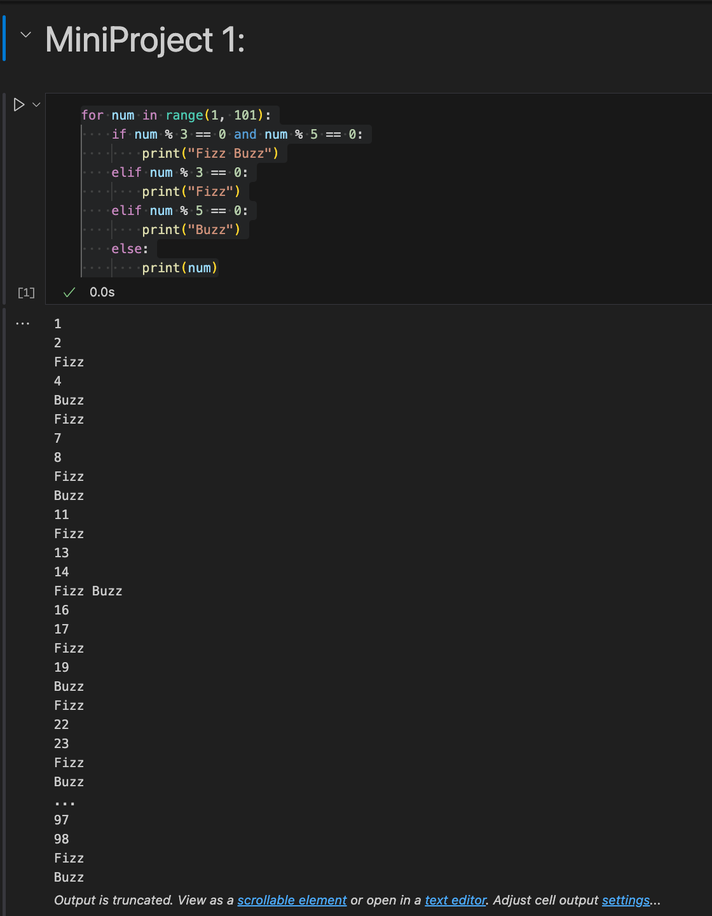

**MiniProject 2**

**In particular we're going to finding the average budget of the films in our data set, and we're going to identify high budget films that exceed the average budget we calculate.**

Solution:

1. This program is based on list of movies each having name and budget in this code we will find average of movies then difference between avergae and budget.
2. First it will ask the user how many movies he want to enter then acording to demad it will enter the total movies with name and budget
3. Then list comprehension [budget for name, budget in movies] is used to extract only the budgets into a separate list for calculating average
4. At the end, the total number of movies above average is displayed

**Code and output:**

